Ways to Boost Your Brain
as you age
Casey Saylor, MSW Older Adult Project Manager

MHAMD
For more than 100 years, the Mental Health Association of
Maryland has addressed the mental health needs of Marylanders of all ages through programs that educate the public to increase understanding and provide resources, advance public policy to improve care and outcomes, and monitor the quality of services received by individuals living with mental illness and substance use disorders.

AdvocacyAdvocacy
- The Children’s Behavioral Health Coalition
- The Behavioral Health Coalition
- The Maryland Coalition on Mental Health & Aging
- The Maryland Behavioral Health Criminal Justice Partnership
- The Path Forward for Mental Health & Substance Use

^{Education & Outreach}Education and Outreach
- Consumer Quality Team
- Mental Health First Aid
- Engage with
- Health New Moms
- Children’s Mental Health Matters
- Older Adults: Vibrant Minds

Brain Science
Aging is a normal process-
we are aging from the moment of birth.

Normal Changes in the Brain
- Committing new information to memory might require reinforcement
- Recall of data / names / numbers can take longer
- Multi-tasking can slow processes
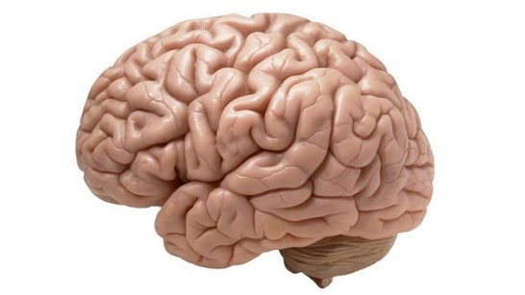
- Brain shrinks raising risk for brain injury
- Metabolism slows raising risk for toxicity

Regardless of age, healthy brains...
- Learn new information
- Create and remember memories
- Adapt to changes and challenges
- Communicate who you are as a person through your personality, behaviors, and beliefs.

The elephant in the room
- Dementia is NOT a normal part of aging.
- Mild cognitive impairment is a common syndrome. May impact memory, sequencing, planning, judgement, communication.
- In normal aging, brains need enrichment. As prevention, encourage things that stimulate brain function.
Read more: Guidebook pp. 42-49
Source: University of Michigan, as published in the Washington Post.

Variance of Onset
Long lived experience: Individuals who first experienced behavioral health conditions during childhood or early adulthood.
Late onset: Individuals who first experienced behavioral health conditions during later life, age 50+.
Late identification: Individuals who may have experienced behavioral health conditions earlier in life but did not recognize them until later life.
Most Common Late Onset conditions
- Anxiety
- Depression
- Alcoholism
Certain events that are common in later life can put our mental wellness
at risk. What events? Type your ideas into the chat box.
Red Flag Experiences: Health p.15
- Family history of brain disorders
- Pain or disability
- Change in health status
- Certain health conditions (diabetes, heart problems, stroke, cognitive impairment)
- Use/misuse/abuse of medications or alcohol
Red Flag Experiences: Emotional
- Loneliness or isolation
- Threats to independence
- Trauma
- Challenges to self-esteem
- Repeated or prolonged stress
Red Flag Experiences: Social
- Change in lifestyle or living arrangements
- Change in financial status
- Caregiving
- Loss of a loved one • Loss of social supports
- Family conflict and estrangement
- Problems in managing leisure time / boredom
General Warning Signs
- Marked personality change
- Difficulty coping with problems and daily activities / lack of self care
- Strange or grandiose ideas
- Excessive anxieties
- Prolonged depression or apathy
- Marked changes in eating or sleeping patterns
- Extreme mood swings – high or low
During COVID-19

Common reactions to crisis/ pandemic
- Increased anxiety and fear about finding resources.
- Uncertainty: how do we plan for today, tomorrow, 6 months from now.
- Checking with selves and others about symptoms.
- Excessive sanitizing and cleaning.
- Hypervigilance.
- Don’t know how to keep themselves and others safe.
Have you personally experienced one or more of these reactions?
If so, type “yes” into the chat box.

A Positive Outcome
Erasing stigma of mental illness
- Normalizing anxiety and depression
- Relationship between mental health & physical health
- Increased need for help: mental health and addiction services ● Self care and social support
On the Stigma of COVID-19: Psychology Today
If you’re experiencing any of the following, it’s time to address your stress:
- increased use of alcohol, tobacco, or other substances
- loss of hope, purpose, or compassion for others; having low energy
- worsening of chronic health problems
- returning/ worsening symptoms of mental health, substance use, or eating disorder problems

Tips for Coping
- Create new routines and keep the routines that make you feel good.
- If you take medication, continue taking it as prescribed and refill your prescriptions as early as possible.
- Stay in touch with the people you care about.
- Connect with others through virtual therapy and support.
- Minimize media consumption.

Other Tips
- Challenge your distorted perceptions around groups impacted by the virus.
- Treat those who are diagnosed with the virus with dignity and respect.
- Physical distancing, not social distancing. Connect with your friends & community.
- Empower survivors to share their stories.
- Continue normalizing mental wellness for yourself & your neighbors.
Practical Tips for Managing your
Mental Wellness
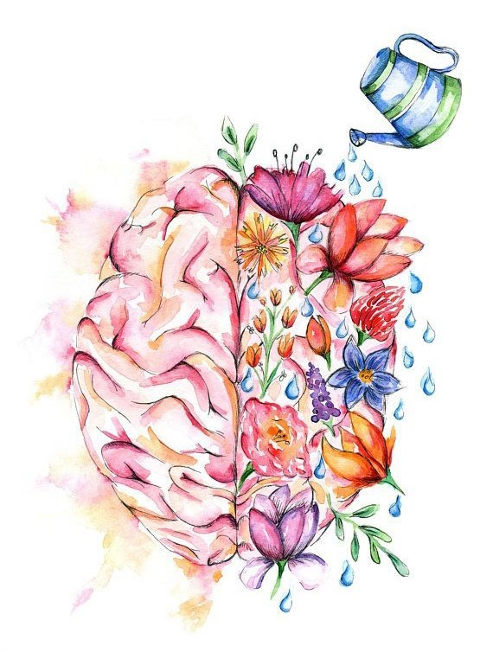
What do you do to take care of your brain?
Share in the chat box.
27
Priorities for wellness
Quality of Life Needs
- Meaningful engagement
- Positive connection to others
- Resiliency & flexibility
- Mindfulness & stress control
- Freedom from threat and fear
- Hope
Stress IN MODERATION
Positive stress is called Eustress. It can help you accomplish goals and meet deadlines. Eustress provides mental alertness, motivation, and efficiency. Eustress can increase self-esteem.

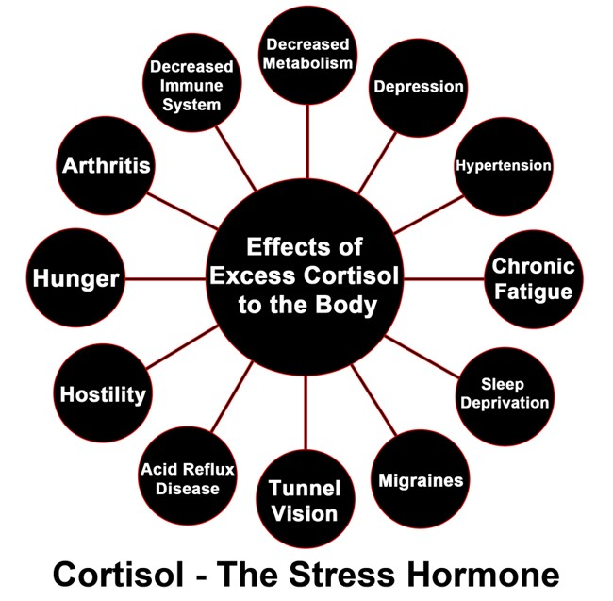

Managing Stress
- Exercise regularly.
- Take the time to try new things or reinstate old hobbies ● Focus on things you can control.
- Set priorities.
- Control your media consumption.
- Use your support system.
- Communicate hope.

In general
- Create new routines and keep the routines that make you feel good.
- If you take medication, continue taking it as prescribed and refill your prescriptions as early as possible.
- Stay in touch with the people you care about.
- Connect with others through virtual therapy and support.
Resources & Ways to Get Involved
Please share any resources and opportunities for mental wellness that
you know of in the chat box!

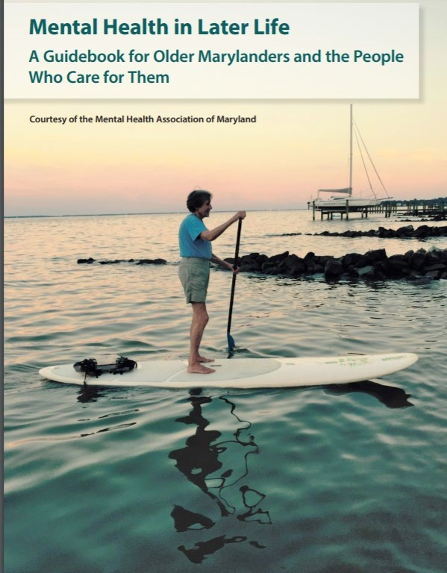
Older Adults Vibrant Minds
- Learn more about aging and the brain at www.mdaging.org Get your free Guidebook!
●
- Start a Guidebook Study Group.
- Join our virtual events on mental wellness ● Older Adults Vibrant Minds is on MeetUp!

Baltimore County Connections Project
A volunteer program to provide supportive phone or video visits to older Baltimore County residents who are being isolated by COVID-19.
- Recruiting volunteers to connect with older adults over phone and/ or video.
- Baltimore County residents can sign up to receive supportive calls.
- Helping other communities to replicate the project.
- Learn more at www.mdaging.org

Resource Recommendations
- For more tips on maintaining mental wellness during COVID-19, visit mhamd.org/coronavirus
- Stigma & COVID-19 compilation: Distorted Perceptions
- For trusted updates on COVID-19, visit www.cdc.gov and coronavirus.maryland.gov
- If you’re concerned about meeting your family’s basic needs, call 211, go to 211md.org/, or text your zip code to 898-211 to connect with local resources.

Resource Recommendations
- Baltimore County Peer Support resource list.
- Peer support warmlines and online support groups are terrific ways to expand your system of supporters. Learn more here mhamd.org/coronavirus/get-help-now/living-with-mental-illness-duringcovid-19-outbreak/ or contact your local Wellness & Recovery Center for information on local support groups.
- Get the Mental Health in Later Life Guidebook!!!

Finding Support
- Contact HR Department or Employee Assistance Program for resources
- Call the Maryland Crisis Hotline at 1-800-422-0009 if you or someone you know is in crisis.
- SAMHSA Mental Health Treatment Facility Locator Toll-Free: 1-800-789-2647 (English and español) http://findtreatment.samhsa.gov/MHTreatmentLocator

Finding Support
- Go to mhamd.org/coronavirus/get-help-now for tips on accessing telehealth and in-person behavioral health services.
- If you're concerned about your stress or mental health, take an online mental health screen and get connected to resources that can keep it from getting worse: screening.mhanational.org/screening-tools
Questions?
Casey Saylor, MSW Older Adult Project Manager
csaylor@mhamd.org
443-470-9426

www.mdaging.or
g
Thank you!
Casey Saylor, MSW Older Adult Project Manager
csaylor@mhamd.org
443-470-9426

www.mdaging.or
g

